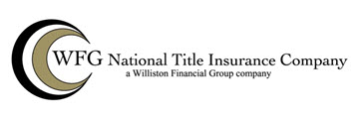

(NAME OF GUARANTEE HERE)
SUBJECT TO THE EXCLUSIONS FROM COVERAGE, THE LIMITS OF LIABILITY AND THE CONDITIONS AND STIPULATIONS OF THIS GUARANTEE,

WFG NATIONAL TITLE INSURANCE COMPANY,
a corporation, herein called the Company

GUARANTEES

the Assured named in Schedule A against actual monetary loss or damage not exceeding the liability stated in Schedule A, which the Assured shall sustain by reason of any incorrectness in the assurances set forth in Schedule A.

Issued by:
__________________________________  Authorized Countersignature | 